2D Kinematics with PYTHON!
Open up python on one of the computers (if it is not already open). Download a program called kinematicslab.py from blackboard and save it on your desktop. Open this program with python.
Wait for instructions. We will talk through the code line-by-line.

from pylab import *

acceleration_x = 0 # m/s^2
acceleration_y = -9.8 # m/s^2
velocity_initial = 100 # m/s
velocity_initial_angle = 60 # degrees
v0_x = velocity_initial * cos(velocity_initial_angle*pi/180)
v0_y = velocity_initial * sin(velocity_initial_angle*pi/180)
time_max = 2*v0_y/(-acceleration_y) #sec
time_step = .01 #sec
t = arange(0,time_max, time_step)
x = zeros(len(t))
y = zeros(len(t))

for ii in range(len(t)):
x[ii] = v0_x*t[ii] + 1/2.0*acceleration_x*(t[ii])**2
y[ii] = v0_y*t[ii] + 1/2.0*acceleration_y*(t[ii])**2

plot(x,y,'m.') #plots graph, to change color of dots,
#try 'b.' (blue) , 'm.'(magenta), 'c.' (cyan), 'k.' black, etc.
axis('equal')

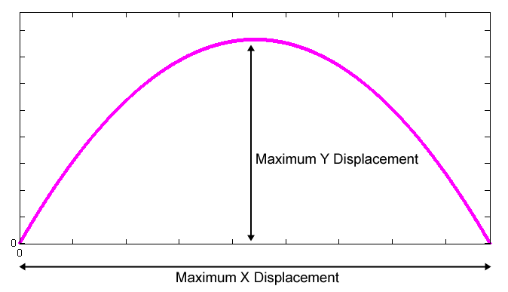
Task 1:
Set the initial velocity to 100 m/s, the initial angle to 60º, the time step to 0.01, and the color to red (‘r.’).

Under the Debug menu, click Save and Run to run the program. This should create a plot showing where a projectile would be located as a function of time. (Click ‘change directory’ if that box pops up.)

Change the initial velocity ‘velocity_initial’ to 50 m/s and plot this in blue.
If you mess up, close the figure and start again.

Using the graphs you created, fill in the “from graph” columns in the table below:

Color |  | V₀ (m/s) | Maximum X  (from graph) | Maximum X  (Calculated) | % error | Maximum Y  (from graph) | Maximum Y  (Calculated) | % error
Red | ‘r.’ | 100
Blue | ‘b.’ | 50
Table 1: Comparison of graphed and calculated maximum displacements in both directions
Use Table 2 to calculate the Maximum X displacement using kinematics and then put it in Table 1.
Fill in Table 2 COMPLETELY, even if you already have figured out your X displacement.

Variable | x (for V₀=100) | y (for V₀=100) | x (for V₀=50) | y (for V₀=50) | units
Time
V_{o}
V_{f}
D
A

Table 2: Kinematic variables used to calculate the maximum displacement in the X direction

Show Work!

Use Table 3 to calculate the Maximum Y displacement using kinematics and then put it in Table 1.
Fill in Table 3 COMPLETELY, even if you already have figured out your Y displacement.

Variable | x (for V₀=100) | y (for V₀=100) | x (for V₀=50) | y (for V₀=50) | units
time
V_{o}
V_{f}
d
a

Table 3: Kinematic variables used to calculate the maximum displacement in the Y direction

Show Work!

Calculate your % errors for Table 1.

Which initial velocity gets the largest horizontal displacement?__________________________
Which initial velocity gets the largest vertical displacement?__________________________

Save your plot by selecting ‘save as’ from the file menu of the figure and giving it a name you know. Change the file type from a ‘.fig’ file to a ‘.jpg’ as you save the file. Save it somewhere you can find it, desktop or in your personal account are good choices. Once it has been saved close your figure.
Task 2:
Make your initial velocity 100 m/s. Change the time_step to be 1, so that it plots a point every 1 second.

Change the initial angle ‘velocity_initial_angle’ and plot each in the different colors given in Table 4.
Then count the number of dots shown in each color. Do not count the dot at (0,0). Since these dots are created after every second of motion, counting them approximates the total time.

Color | Color symbol | Angle (degrees) | Number of dots shown | Calculated Time (sec) | % error
Red | ‘r.’ | 45
Blue | ‘b.’ | 15
Green | ‘g.’ | 30
Black | ‘k.’ | 60
Magenta | ‘m.’ | 75
Table 4: Comparison of graphed times and calculated times for varying angles.

Next, calculate the time it should take, given the initial angle and the initial velocity. Start by filling in the below table, you may leave your answers in terms of theta, and do not need to fill in cells if you don’t need the information to calculate time.
Variable | X | Y | units
Time | ?
V_{o}
V_{f}
D
A
Table 5: Kinematics variables used to calculate the time until the ball hits the ground.

Then show your time calculations, for at least one case and calculate the times for all cases.

Which initial angle gets the largest horizontal displacement?__________________________
Which initial angle gets the largest vertical displacement?__________________________
Which initial angle has the largest time in the air?__________________________

Save your plot by selecting ‘save as’ from the file menu and giving it a name you know. Save it somewhere you can find it, desktop or in your personal account are good choices.

Turn both figures in with your lab. (Email them to yourself and me with all of your names listed and tell me in your lab report that they were emailed by whoever does the emailing.)

